FRACTIONS
Pearson Edexcel - Tuesday 19 May 2020 - Paper 1 (Non-Calculator) Higher Tier
1.
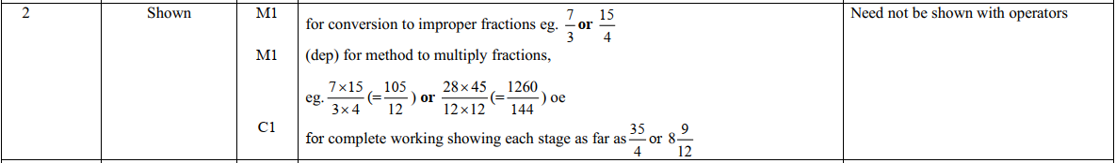
Pearson Edexcel - Tuesday 19 May 2020 - Paper 1 (Non-Calculator) Higher Tier
2.
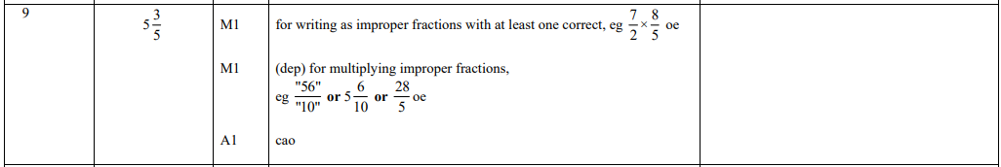
Pearson Edexcel - Thursday 8 November 2018 - Paper 2 (Calculator) Higher Tier
3.
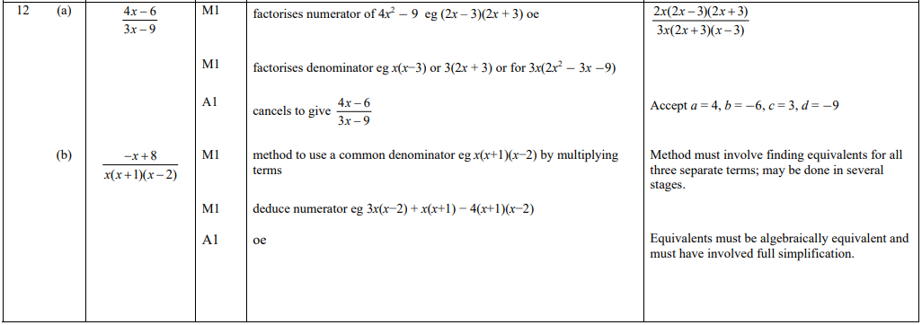
Pearson Edexcel - Thursday 4 June 2015 - Paper 1 (Non-Calculator) Higher Tier
4.
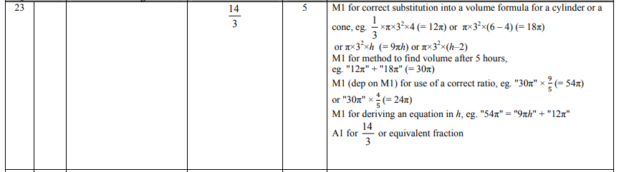

Pearson Edexcel - Monday 6 June 2011 - Paper 3 (Non-Calculator) Higher Tier
5.
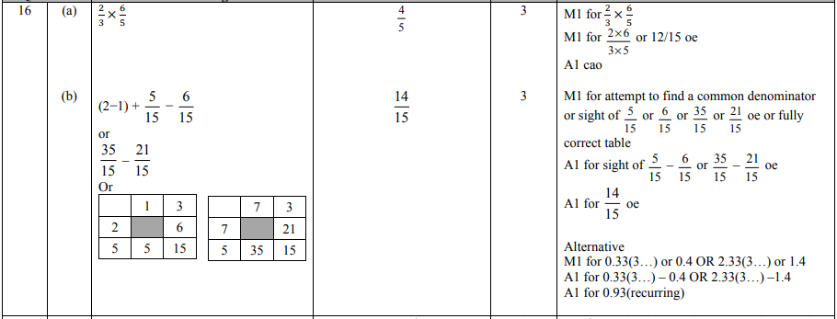
Pearson Edexcel - Friday 10 June 2011 - Paper 4 (Calculator) Higher Tier
6.
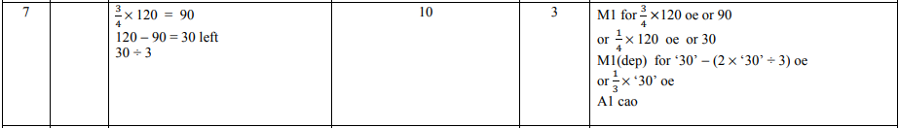
Pearson Edexcel - Tuesday 9 November 2010 - Paper 3 (Non-Calculator) Higher Tier
7.
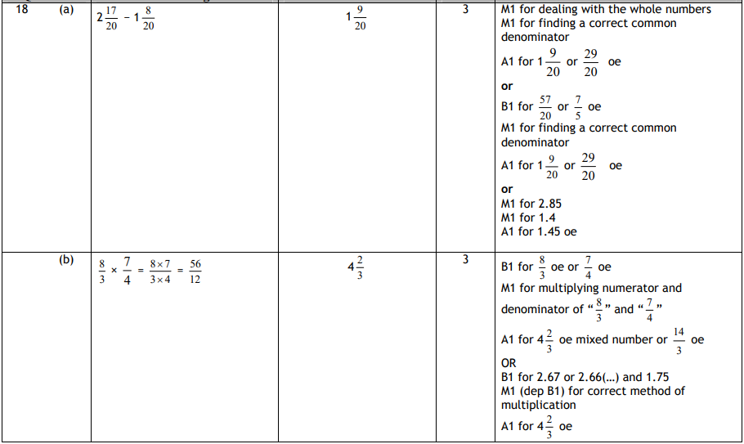

Pearson Edexcel - Monday 7 June 2010 - Paper 3 (Non-Calculator) Higher Tier
8.
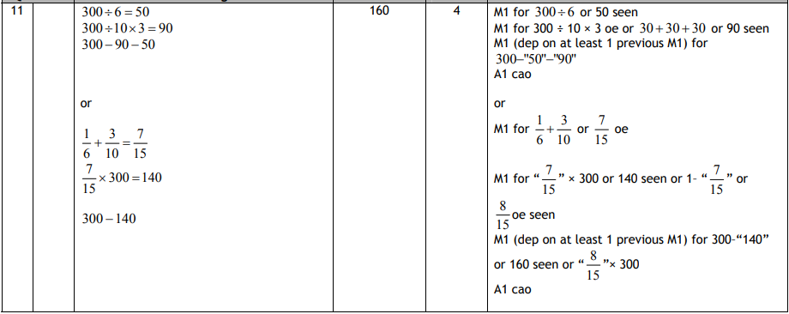
Pearson Edexcel - Monday 7 June 2010 - Paper 3 (Non-Calculator) Higher Tier
9.
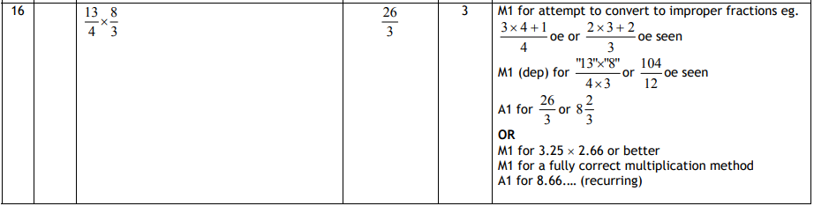
Pearson Edexcel - Thursday 5 November 2009 - Paper 3 (Non-Calculator) Higher Tier
10.
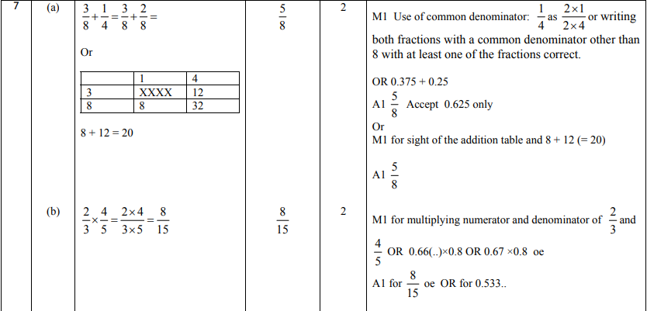
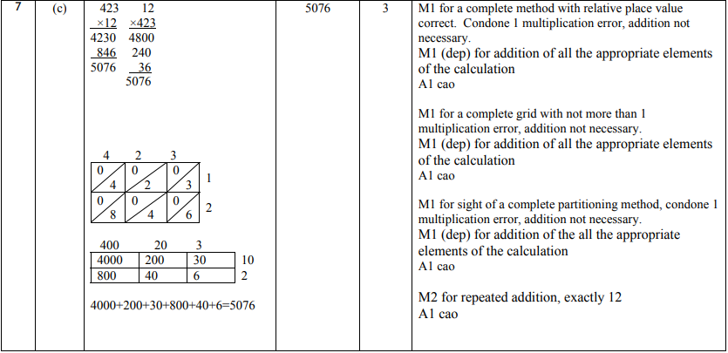
OCR GSCE – Thursday 5 November 2020 – Paper 5 (Non-Calculator) Higher Tier
11.
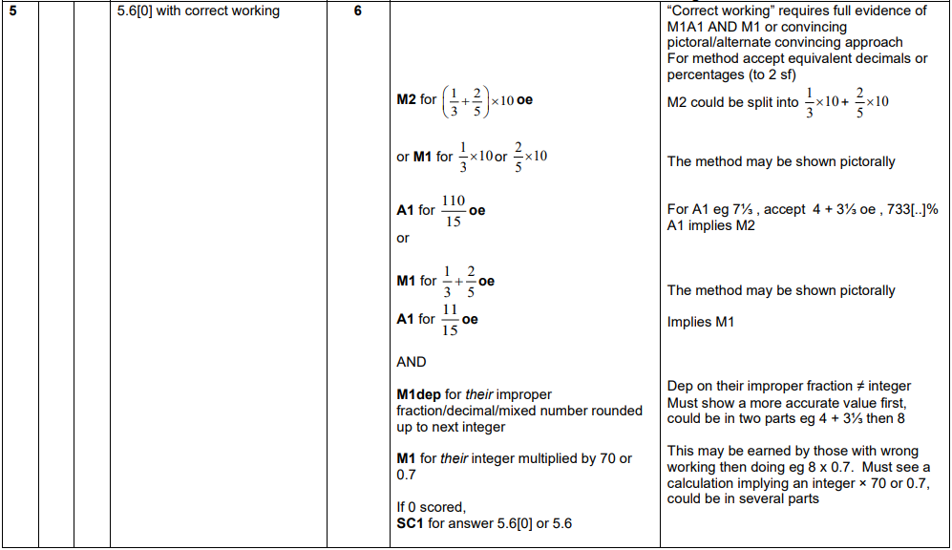

OCR GSCE – Monday 9 November 2020 – Paper 6 (Calculator) Higher Tier
12.
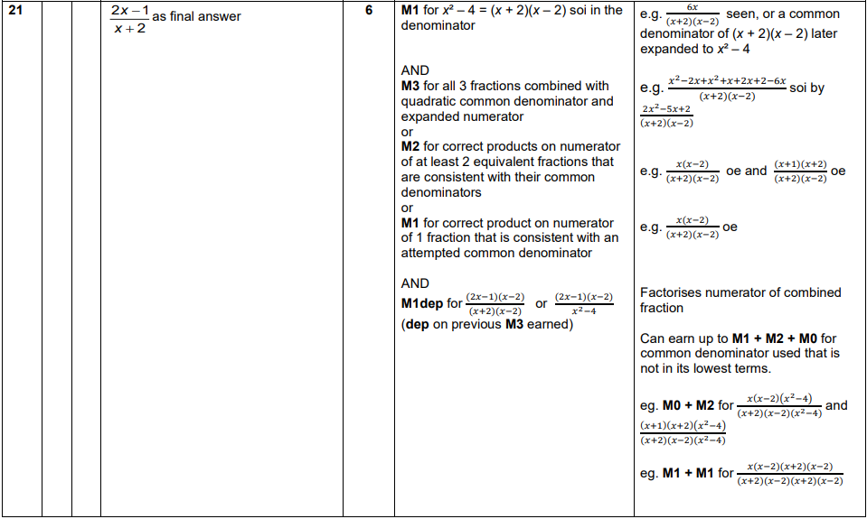
OCR GSCE – Thursday 6 June 2019 – Paper 5 (Non-Calculator) Higher Tier
13.
